Minute
# Source: AI Source: Provided by: [Data Path: Persons Table -> ID Column: 1, Name_En Column: Motasem Essam] -> From: [ChatGPT] on [7/17/2026]
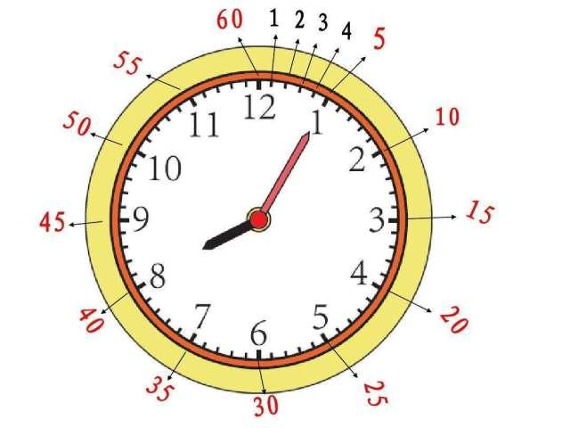
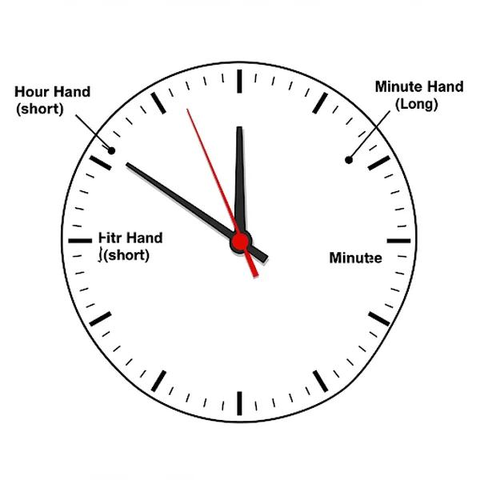
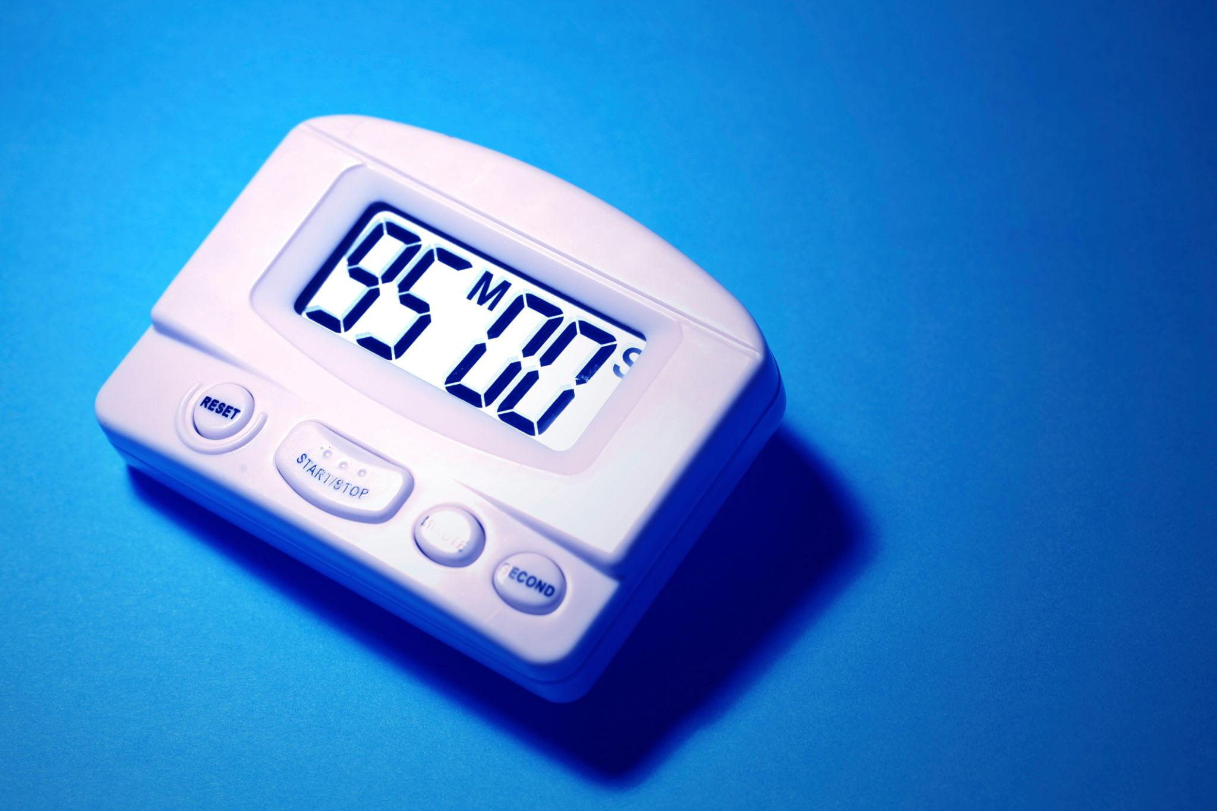
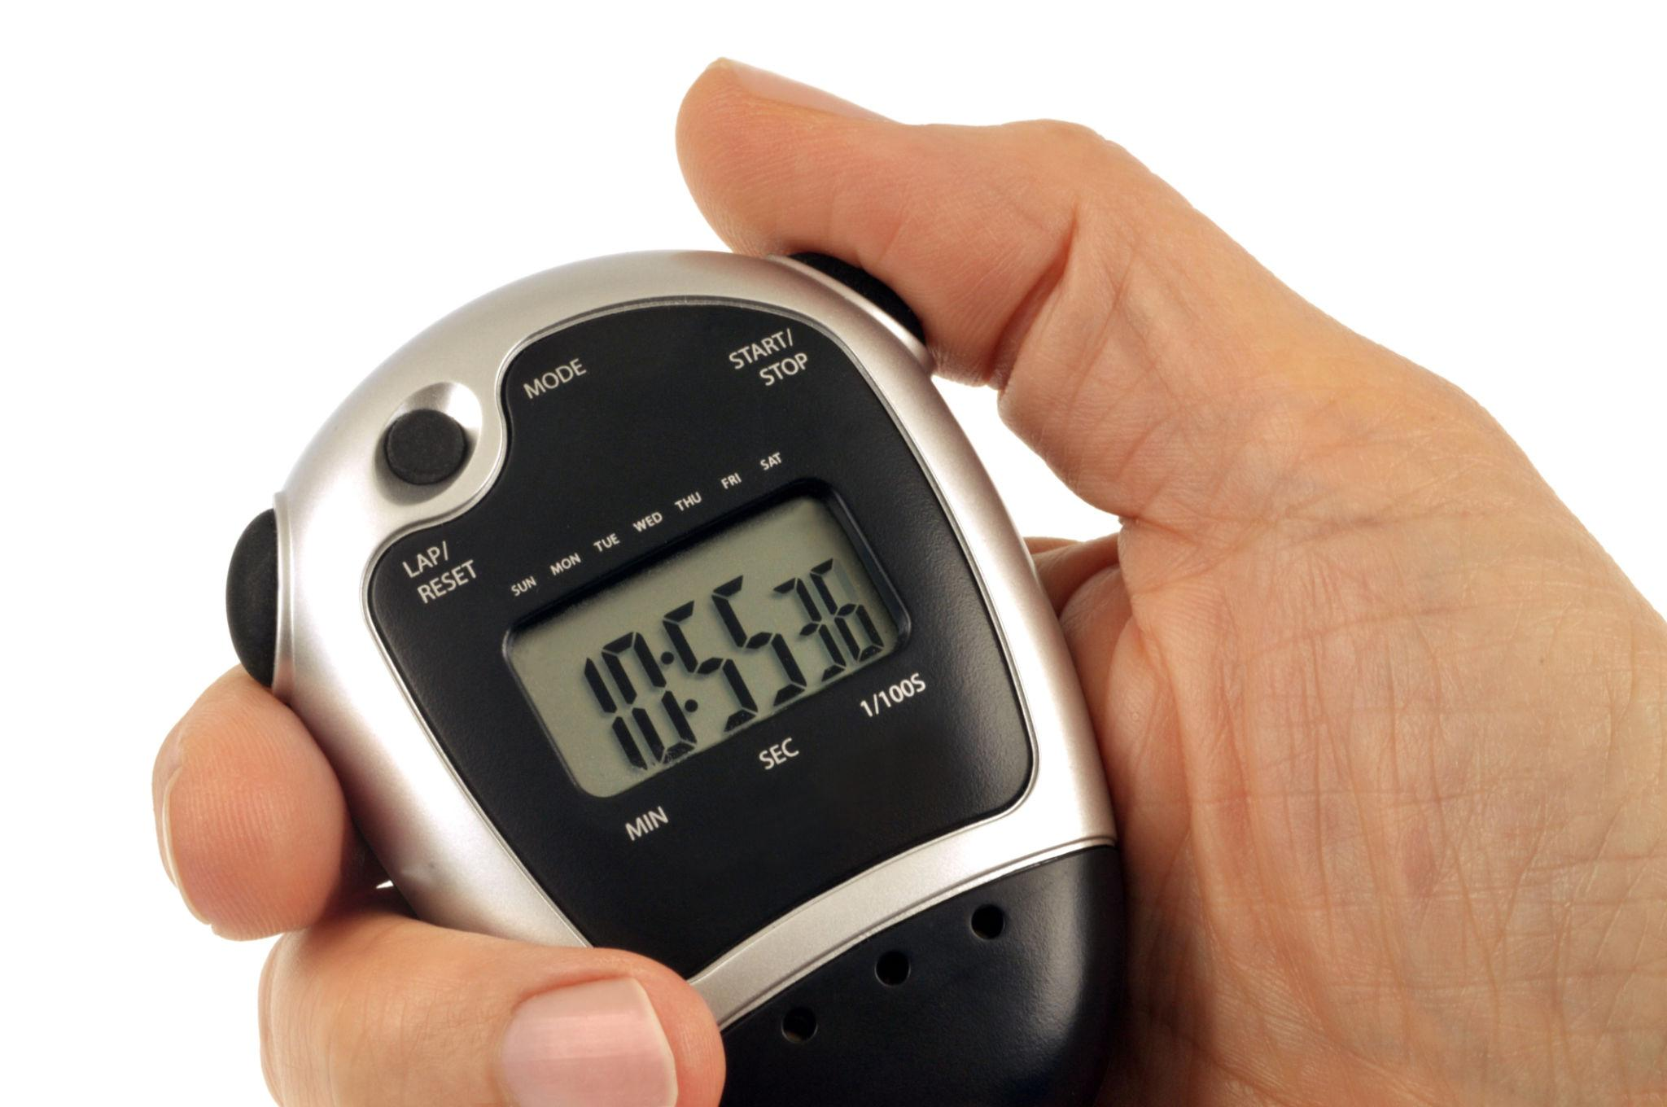
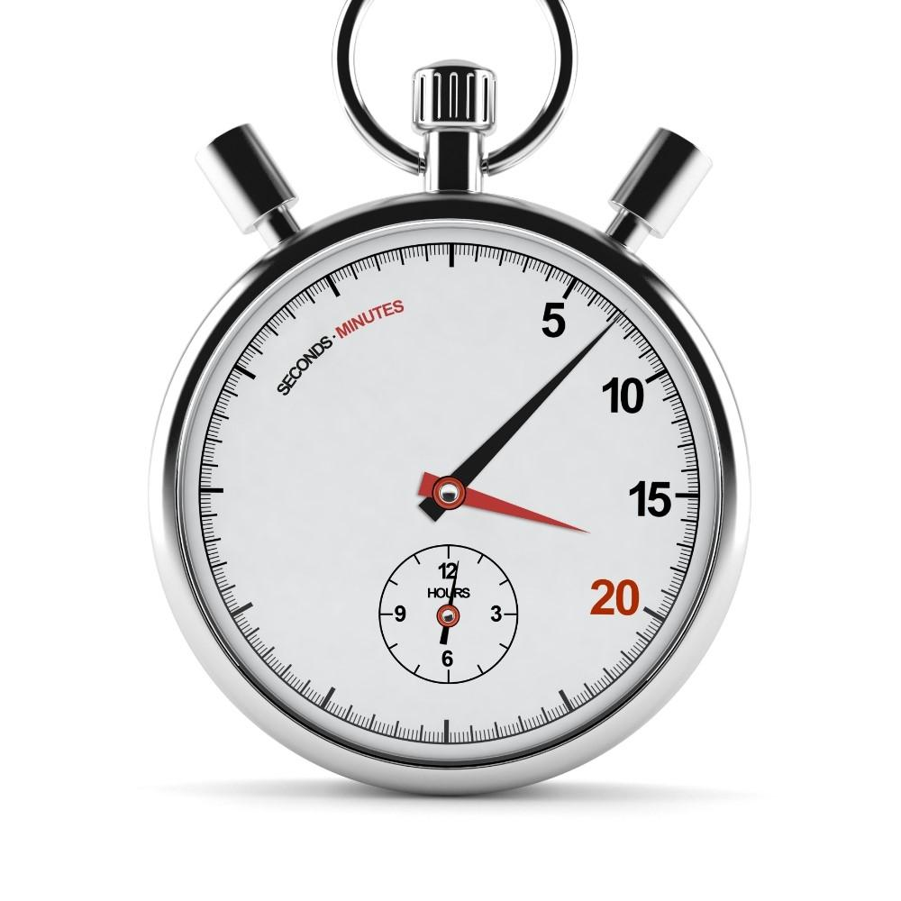
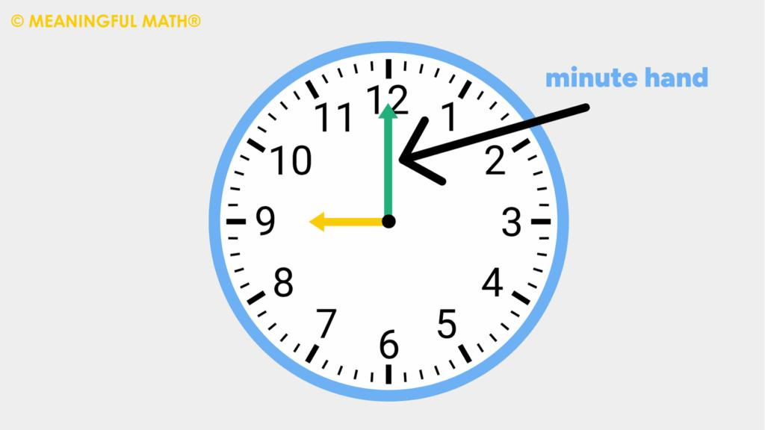
A Minute is a standard unit of time measurement equal to 60 seconds. It is one of the most commonly used units for measuring short periods of time and is widely used in daily life, science, transportation, sports, and technology.
The minute is larger than the second and smaller than the hour.

Definition
# Source: AI Source: Provided by: [Data Path: Persons Table -> ID Column: 1, Name_En Column: Motasem Essam] -> From: [ChatGPT] on [7/17/2026]
A Minute is a unit of time equal to 60 seconds or one-sixtieth (1/60) of an hour.

Standard Length
# Source: AI Source: Provided by: [Data Path: Persons Table -> ID Column: 1, Name_En Column: Motasem Essam] -> From: [ChatGPT] on [7/17/2026]
Standard Length
One minute equals:
- 60 seconds
Mathematically:
$$1\text{ minute}=60\text{ seconds}$$

Relationship to Other Time Units
# Source: AI Source: Provided by: [Data Path: Persons Table -> ID Column: 1, Name_En Column: Motasem Essam] -> From: [ChatGPT] on [7/17/2026]
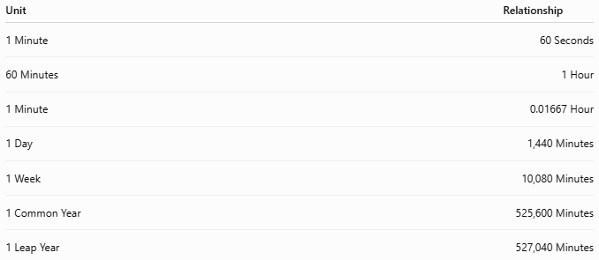
Unit | Relationship
1 Minute | 60 Seconds
60 Minutes | 1 Hour
1 Minute | 0.01667 Hour
1 Day | 1,440 Minutes
1 Week | 10,080 Minutes
1 Common Year | 525,600 Minutes
1 Leap Year | 527,040 Minutes

Abbreviation
# Source: AI Source: Provided by: [Data Path: Persons Table -> ID Column: 1, Name_En Column: Motasem Essam] -> From: [ChatGPT] on [7/17/2026]
The standard abbreviation is:
- min
Examples:
- 5 min
- 30 min
- 90 min

Historical Background
# Source: AI Source: Provided by: [Data Path: Persons Table -> ID Column: 1, Name_En Column: Motasem Essam] -> From: [ChatGPT] on [7/17/2026]
The minute originated from the ancient practice of dividing an hour into 60 equal parts using the sexagesimal (base-60) number system developed by the Babylonians.
The word minute comes from the Latin phrase pars minuta prima, meaning "first small part."

Measuring Minutes
# Source: AI Source: Provided by: [Data Path: Persons Table -> ID Column: 1, Name_En Column: Motasem Essam] -> From: [ChatGPT] on [7/17/2026]
Minutes are measured using:
- Analog clocks
- Digital clocks
- Watches
- Stopwatches
- Timers
- Smartphones
- Computer system clocks

Minute Hand on an Analog Clock
# Source: AI Source: Provided by: [Data Path: Persons Table -> ID Column: 1, Name_En Column: Motasem Essam] -> From: [ChatGPT] on [7/17/2026]
On a traditional clock:
- The minute hand is the longer hand.
- It moves:
  - One mark every minute
  - One complete revolution every 60 minutes

Common Examples
# Source: AI Source: Provided by: [Data Path: Persons Table -> ID Column: 1, Name_En Column: Motasem Essam] -> From: [ChatGPT] on [7/17/2026]
Examples of durations measured in minutes:
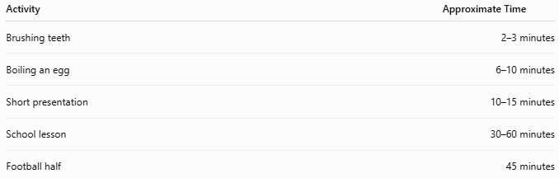
Activity | Approximate Time
Brushing teeth | 2–3 minutes
Boiling an egg | 6–10 minutes
Short presentation | 10–15 minutes
School lesson | 30–60 minutes
Football half | 45 minutes

Applications
# Source: AI Source: Provided by: [Data Path: Persons Table -> ID Column: 1, Name_En Column: Motasem Essam] -> From: [ChatGPT] on [7/17/2026]
Minutes are used in:
- Daily schedules
- Transportation timetables
- Sports competitions
- Cooking
- Scientific experiments
- Medical procedures
- Computer timing
- Industrial processes

Conversion Examples
# Source: AI Source: Provided by: [Data Path: Persons Table -> ID Column: 1, Name_En Column: Motasem Essam] -> From: [ChatGPT] on [7/17/2026]
Conversion Examples
Minutes to Seconds
Multiply by 60.
Example:
$$5\text{ min}=5×60=300\text{ s}$$
Seconds to Minutes
Divide by 60.
Example:
$$180\text{ s}=180÷60=3\text{ min}$$
Minutes to Hours
Divide by 60.
Example:
$$90\text{ min}=90÷60=1.5\text{ h}$$
Hours to Minutes
Multiply by 60.
Example:
$$2\text{ h}=2×60=120\text{ min}$$

Advantages
# Source: AI Source: Provided by: [Data Path: Persons Table -> ID Column: 1, Name_En Column: Motasem Essam] -> From: [ChatGPT] on [7/17/2026]
Using minutes allows:
- Accurate scheduling
- Precise time measurement
- Easy conversion to seconds and hours
- Standardized communication worldwide

Common Mistakes
# Source: AI Source: Provided by: [Data Path: Persons Table -> ID Column: 1, Name_En Column: Motasem Essam] -> From: [ChatGPT] on [7/17/2026]
- Confusing minutes with seconds.
- Assuming 100 minutes = 1 hour (it is 60 minutes).
- Confusing the minute hand with the hour hand on an analog clock.

Interesting Facts
# Source: AI Source: Provided by: [Data Path: Persons Table -> ID Column: 1, Name_En Column: Motasem Essam] -> From: [ChatGPT] on [7/17/2026]
- There are 1,440 minutes in one day.
- A clock's minute hand completes 24 full rotations each day.
- Minutes are part of the internationally standardized International System of Units (SI) accepted units for time, although the SI base unit is the second.

Key Points
# Source: AI Source: Provided by: [Data Path: Persons Table -> ID Column: 1, Name_En Column: Motasem Essam] -> From: [ChatGPT] on [7/17/2026]
- A Minute equals:
$$60\text{ seconds}$$
- 60 minutes = 1 hour.
- Minutes are commonly abbreviated as min.
- They are measured using clocks, watches, timers, and stopwatches.
- Minutes are widely used for scheduling, transportation, sports, science, and everyday activities.

Conclusion
# Source: AI Source: Provided by: [Data Path: Persons Table -> ID Column: 1, Name_En Column: Motasem Essam] -> From: [ChatGPT] on [7/17/2026]
A Minute is a fundamental unit of time equal to 60 seconds and one-sixtieth of an hour. It provides a convenient way to measure short durations and is used universally in daily life, science, transportation, education, and technology. As one of the most practical units of time, the minute serves as an essential link between the second and the hour, enabling accurate and standardized timekeeping around the world.

